Problem G. Trend

A market trend is a perceived tendency of the price of assets (currencies, stocks, etc.) traded on financial markets to move in a particular direction over time. Traders identify market trends using technical analysis, a framework which characterizes market trends as predictable price tendencies within the market. These include time points when the price reaches support and resistance levels, varying over time. A trend can only be determined in hindsight, since at any time prices in the future are not known.
The terms "bull market" and "bear market" describe upward and downward market trends, respectively. They can be used to describe either the market as a whole or specific sectors and securities. The names perhaps correspond to the fact that a bull attacks by lifting its horns upward, while a bear strikes with its claws in a downward motion.
An IT company made analysis of EUR/USD currency rate’s bull market for different time intervals and stored it on a hard drive. Due to a hardware failure, a mixing of the historical series occurred that caused all available data to be combined in a common series. You are a software engineer in the company and have the task to restore the original upward trends from the mixed data. The data creators help you by restoring the expected number of trends stored in the data set. You have to create an efficient program that will decide how many bull market trends there are actually in the data. The condition is to have no intersecting trends.
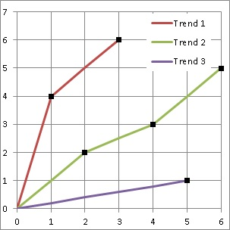
An example is shown on the figure. The vertical axis contains the market values and the horizontal - the time points. Both of them are marked with numbers from 1 to N. The figure corresponds to example input 1. All upward trends start from point 0 which is not included in the data.

Input
The first row contains an integer number 1<=T<=20, representing the number of tests cases in the set. Every test case begins with a row containing two numbers: an integer 1<=N<=50000, determining the maximal value of the two axes and another integer 1<=L<=50000 – the number of the upward trends that are expected in the test case. Following is a row containing N different integer numbers representing the market values of the financial asset in time. Every i-th number in the row corresponds to the i-th time point (position on the horizontal axis). The numbers in the row are delimited with spaces.

Output
For every test case you will have to output a row containing the calculated minimal number of upward trends (it has to be less than or equal to L). If the calculated number is larger than L, you have to output the text impossible.
Example Input | Example Output
2  6 3  4 2 6 3 1 5  8 3  8 7 6 5 4 3 2 1 | 3  impossible

